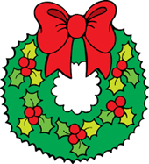
Moravian Center Adult Day
December Calendar
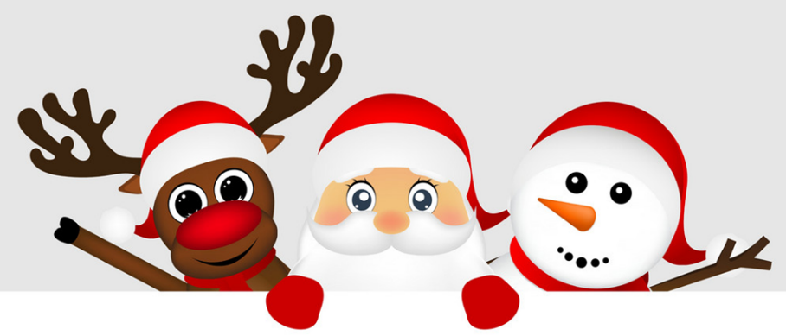

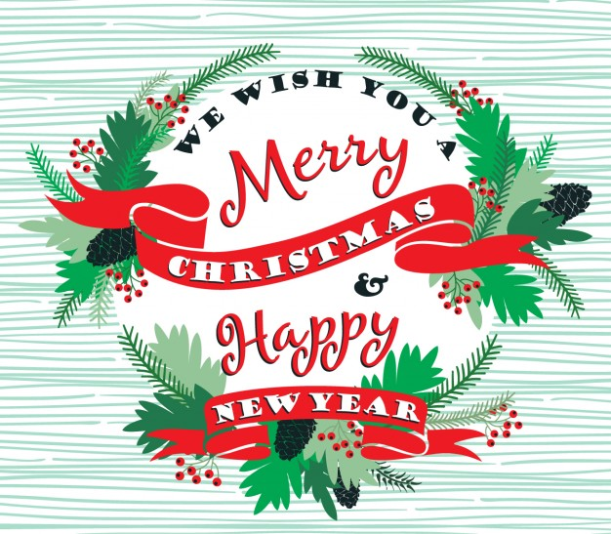

*December Announcements*
*Wear Your Ugly Xmas Sweater Day *
12/17
*Center Closed *
12/24 (Xmas Eve)
12/31 ( New Year’s Eve)

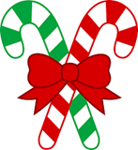
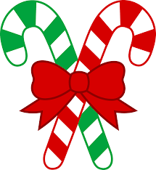
December Activity Calendar
Week 1
Time | Wed – 1 |  | Thursday – 2 |  | Friday – 3
7:30 | Coffee Corner |  | Coffee Corner |  | Coffee Corner
9:30 | St. Nicholas Inf. |  | Current Events |  | Devotions
10:00 | Dance Moves |  | Yoga |  | Fit & Strong
11:00 | Spirit Time |  | Reindeer Art |  | QT Snowflake
12:00 | Lunch |  | Lunch |  | Lunch
1:00 | Baseball Toss  Bocci Ball  Darts Game |  | Basket ball  Bocci Ball  Golf |  | Frisbee Toss  Bean Bag Toss  Parachute
2:00 | Scattergories |  | Board trivia |  | Poker Fun
3:00 | Snack & Chat |  | Snack & Chat |  | Snack & Chat
4:00 | Card Games |  | Connect 4 |  | Uno
 | National Pie Day | National Mutt Day |  | National Roof Over your head Day
Week 2
Time | Monday – 6 | Tuesday - 7 | Wed – 8 | Thursday – 9 | Friday - 10
7:30 | Coffee Corner | Coffee Corner | Coffee Corner | Coffee Corner | Coffee Corner
9:00 | Stories | Current Events | Bird Stories | Navidades Info | Devotions
10:00 | Chair Exercise | Fit & Strong | Dance Moves | Chair Exercise | Fit & Strong
11:00 | Christmas  cards | Penguin Art | Spirit Time | Christmas Craft | Christmas tree Crafts
12:00 | Lunch | Lunch | Lunch | Lunch | Lunch
1:00 | Basketball  Bocci Ball  Golf | Soccer Golf Darts | Baseball Toss  Shuffleboard  Parachute | Volleyball  Bocci Ball  Basketball | Tic Tac Toe To  Frisbee Toss  Bean Bag Toss
2:00 | Bulletin Board Trivia | Bingo Bonanza | Scattergories | Name 5 | Magazine Hunt
3:00 | Snack & Chat | Snack & Chat | Snack & Chat | Snack & Chat | Snack & Chat
4:00 | Scrabble | Card Games | Yahtzee | Loose Memory | Tenzi
 | St. Nicholas Day | National Illinois Day | National Brownie Day | Christmas Card Day | Nobel Prize Day

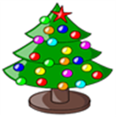
December Activity Calendar
Week 3
Time | Monday – 13 | Tuesday - 14 | Wed – 15 | Thursday – 16 | Friday- 17
7:30 | Coffee Corner | Coffee Corner | Coffee Corner | Coffee Corner | Coffee Corner
9:00 | Stories | Current Events | Stories | Xmas Story | Devotions
10:00 | Chair Exercise | Fit & Strong | Dance Moves | Yoga | Fit & Strong
11:00 | Elves Craft | Snow Globe | Spirit Time | Xmas Cone Art | Santa Art
12:00 | Lunch | Lunch | Lunch | Lunch | Lunch
1:00 | Ring Toss  Ping pong Toss  Bean bag Toss | Basketball  Kickball  Volley Ball | Baseball Toss  Shuffle Board  Darts Game | Tic Tac Toe To  Frisbee Toss  Bean Bag Toss | Table Games  Xmas Movie
2:00 | Jeopardy | Outburst | Bingo Bonanza |  | Poker Fun
3:00 | Snack & Chat | Snack & Chat | Snack & Chat |  | Snack & Chat
4:00 | Card Games | Yahtzee | Dominoes |  | Scrabble
 | National Violin Day | National Alabama Day | National Wear your Pearls Day | National Chocolate -Covered Anything Day | National Ugly Christmas Sweater Day

Time | Monday - 20 | Tuesday - 21 | Wed – 22 | Thursday – 23 | Friday - 24
7:30 | Coffee Corner | Coffee Corner | Coffee Corner | Coffee Corner | Coffee Corner
9:00 | Xmas Stories | Xmas Stories | Current Events | New Year’s Stories | Devotions
10:00 | Fit & Strong | Fit & Strong | Dance Moves | Balance Exercise | Fit & Strong
11:00 | Painting Snow  Globe | Handprint Santa | Spirit Time | 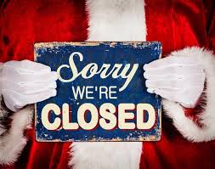  Xmas Fairy House | PP Baubles
12:00 | Lunch | Lunch | Lunch | Lunch | Lunch
1:00 | Wii  Volleyball  Bocci Ball | Bocci Ball  Bean Bag Toss  Ring Toss | Baseball Toss  Bocci Ball  Darts Game | Movie | Golf  Bocci Ball  Santa Wish
2:00 | Bean Bag Toss | Poke-No | Bingo Bonanza | Pictionary | Poker Fun
3:00 | Ring Toss | Snack & Chat | Snack & Chat | Snack & Chat | Snack & Chat
4:00 | Poke-No | Dice Games | Scrabble | Card Games | Connect 4
 | National Sangria Day | Winter Solstice | Forefathers Day | National Roots Day | National Card Playing Day

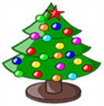
December Activity Calendar
Time | Monday – 27 | Tuesday - 28 | Wed -29 | Thursday- 30 | Friday-31
7:30 | Coffee Corner | Coffee Corner | Coffee Corner | Coffee Corner | Coffee Corner
9:00 | Stories | Current Events | Stories | Xmas Story | Devotions
10:00 | Chair Exercise | Fit & Strong | Dance Moves | Yoga | Fit & Strong
11:00 | Elves Craft | Snow Globe | Table Games | New Year Art | Countdown Art
12:00 | Lunch | Lunch | Lunch | Lunch | Lunch
1:00 | Ring Toss  Ping pong Toss  Bean bag Toss | Bocci Ball  Kickball  Volleyball | Baseball Toss  Shuffle Board  Darts Game | Tic Tac Toe To  Frisbee Toss  Bean Bag Toss | 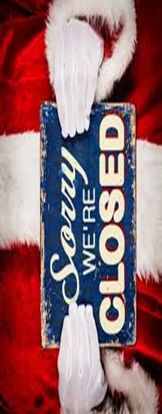  Soccer Golf Darts
2:00 | Jeopardy | Outburst | Bingo | Pictionary | Family Feud
3:00 | Snack & Chat | Snack & Chat | Snack & Chat | Snack & Chat | Snack & Chat
4:00 | Card Games | Yahtzee | Dominoes | Scrabble | Jenga
 | National Fruitcake Day | National Card playing Day | Tick Tock Day | Bacon Day | New Years Eve

